**Qtext:-**

Consider the space-time diagram shown in Fig. 1. The scalar clock values of the events ***a***, ***b***, ***c*** and ***d***are 1, 3, 4 and 2 respectively. Identify the scalar timestamps of the rest of the events and the scalar timestamps of the messages exchanged among the 4 processes. Use **R1** and **R2** for updating the scalar clocks. Assume increment value d = 2.                  [10]

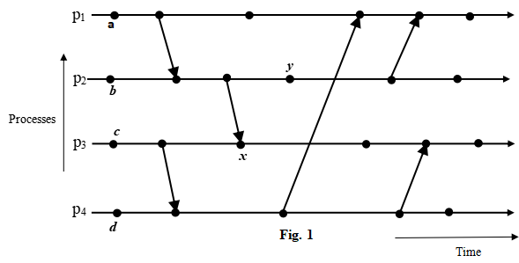

Are the scalar timestamps of events ***x*** and ***y*** same? If yes, then with proper justification, show how you can totally order ***x*** and ***y***?                 [1 + 1 = 2]

**Qtext:-**

Suppose you have an 8-dimensional hypercube. Consider the two nodes having labels 01101100 and 01001100. Are these 2 nodes adjacent to one another? Justify your answer.    [1]

Determine the length of the shortest path between the nodes having the labels ? 11001010 and 01110110. Show your calculation.    [1]

**Qtext:-**

Consider the space-time diagram for 3 processes shown in Fig. 2. Determine whether the cut C is consistent or inconsistent. Justify your answer.     [2]

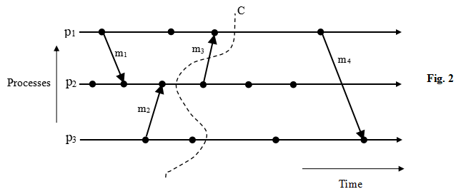

**Qtext:-**

Suppose a distributed system contains 13 sites ? S1, S2, S3, S4, S5, S6, S7, S8, S9, S10, S11, S12 and S13. Here K = 4. Consider the following request sets:

* R2 = {S2, S3, S7, S10}
* R7 = {S4, S8, S10}
* R11 = {S4, S7, S9, S11}
* R12 = {S2, S8, S10, S12}

Determine which of the conditions of M1, M2, and M3 have been violated while constructing the above request sets. Give proper explanation. You do not have to worry about M4 and the request sets of the remaining sites.             [6]

**Qtext:-**

Consider the timing diagram of Fig. 3. The timing diagram shows 2 processes P1 and P2 of a distributed system. C12is the communication channel from P1 to P2 and C21 is the communication channel from P2 to P1. P1 has 2 local variables A and B. P2 has 2 local variables X and Y. The dashed vertical lines denote the different time instants of this timing diagram. Initially, at time instant t1, the values of the local variables of P1 are ? A = 18, B = 30 and the values of the local variables at P2 are ? X = 25, Y = 17. Between time instants t1 and t2, P2 sends message m1 to P1. The content of m1 is ?change B to 15?. P1 receives m1 between t3 and t4 and accordingly changes the value of B. Between t3 and t4, P2 sends message m2 to P1. The content of m2 is ?change A to 35?. P1 receives m2 between t4 and t5 and accordingly changes the value of A. P1 sends message m3 to P2 between t5 and t6. The content of m3 is ?change Y to 40? and P2 receives this message between t6 and t7. P2 changes the value of Y accordingly. The messages m1, m2 and m3 are shown using bold arrows in the diagram. Assume that the Chandy-Lamport algorithm is executed on this distributed system for recording the global snapshot. P1 initiates the snapshot recording algorithm by sending a marker to P2 after time instant t1. P2 receives this marker after time instant t4 and sends a marker to P1. P1 receives this marker after t6. The sending and the receiving of markers are shown using dotted arrows in the Figure. Describe howthe Chandy-Lamport algorithm records the local states of P1 and P2 and the states of the channels C12 and C21. Note that the values of the individual local variables constitute the state of each process.              [6]

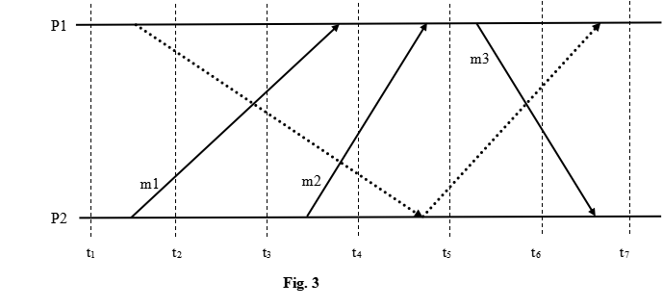

**Qtext:-**

Consider a distributed system consisting of 5 processes as depicted in Fig. 4. The sites have not been shown in the diagram. You are not required to consider any site for answering the questions.

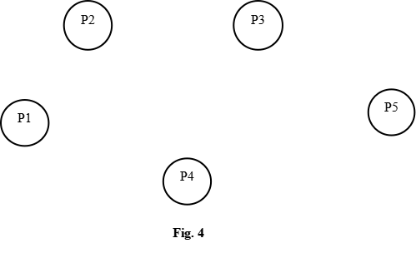

The following dependencies exist among the processes:

* P1 is blocked and is waiting for P4 to release some resource
* P4 is blocked and is waiting for P3 to release some resource
* P3 is blocked and is waiting for P2 to release some resource
* P2 is blocked and is waiting for P1 to release some resource
* P5 is blocked and is waiting for P3 to release some resource

Draw the WFG for the above scenario.                       [1]

Execute Chandy-Misra-Haas algorithm for the OR model on this distributed system to determine whether any deadlock exists in the system. Assume P2 initiates the algorithm. Note that the deadlock is to be detected by using the algorithm and not by any other means.  [9]

Consider a synchronous distributed system consisting of 8 processes ? P1, P2, P3, P4, P5, P6, P7 and P8. Every process puts forth an initial integer value. The initial values put forth by P1, P2, P3, P4, P5, P6, P7 and P8 are 4, 1, 3, 4, 8, 7, 6 and 6 respectively. P2, P3 and P6 are faulty processes and the non-faulty processes are aware of this fact. Using your knowledge of the interactive consistency problem, determine the 8 values of the final agreement array. Assume that for a faulty process, the agreed upon value by all the non-faulty processes is 9. You do not need to consider how many maximum faulty processes can be tolerated by the system.     [2]

**Qtext:-**

Suppose a synchronous system consists of 16 processes out of which 5 processes are faulty. Assume that the Byzantine agreement tree algorithm is executed on this system.

What will be the total number of rounds for the algorithm?     [1]

Each message will be sent to how many nodes in the last round?

**Qtext:-**

A Chord ring with m = 8 contains the following nodes ? N20, N55, N62, N86, N95, N111, N137, N161, N180, N220, and N237.

The chord ring contains the following keys ? K5, K30, K105 and K200. Identify on which node each of the above-mentioned keys will be placed for this Chord ring. You should clearly mention the reason for placing each key on a particular node. You are not required to draw any diagram for answering this question.             [4]

Suppose for this Chord ring, a lookup for K105 is initiated at N55. Describe the step-by-step procedure by which K105 can be located using the simple lookup algorithm. Write the steps of the algorithm clearly in text. You are not required to draw any diagram. If you answer this question by only drawing a diagram, no marks will be awarded.                        [4]